From Turbo2 to TurboWin
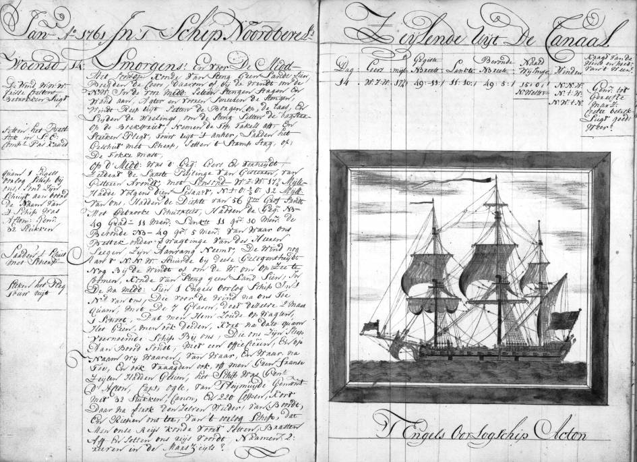
For ages already, information about the weather on board ships was recorded in the ship logbook. From about the middle of the 19th century the ‘meteorological logbook’ came into use, in which the meteorological observations were recorded according certain specifications. In the Netherlands this habit continued until the end of the 20th century. Until then, Dutch ships sent in their completed meteo logbooks regularly to the KNMI, where the information was copied (keyed) and put into databases. Apart from that this was becoming an increasingly expensive procedure, and despite the fact it was done carefully, errors were introduced. Before the observations finally were stored in the database, they were subjected to an extensive, nearly completely automated, quality check.
During all these years, the paper meteo logbook principally didn’t see many revisions. There generally were some meteorological codes that were changed or extended every now and then. The observers needed to know these codes fairly well to be able to complete the observations within limited time. Especially for the less experienced officers this was not an easy task. Except that the observation was recorded in the meteo logbook, it was also copied onto a separate form that subsequently was transmitted by the radio officer (sparks) in morse through radio telegraphy. All together there were several sources of error in the chain. With the arrival of the computer, a complete or partially automated procedure for this was investigated. How could the observation that was made on board ships eventually be entered into the final observations database with as small a number of errors as possible?
Already in 1986 people at KNMI started thinking about a solution for on one side the increasing costs for the digitization of the observation and on the other side to reduce the number of errors in the observations. The general thought was that at least it should be simpler for the observers on board. No – or as little as possible – use of meteorological codes and an as close to the nautical jargon related use of language would aid to that. Also, with the coming abolishment of the radio officers on board, it was essential that a transmission method was developed, that was easy to handle by the officers. Especially for the latter part, the development was done in collaboration with Radio Holland. KNMI developed the meteorological part, while Radio Holland did the transmission part.
Initially a program was developed that had no graphical interface. It ran under the operating system MsDOS and was called, suggesting a ‘speedy’ character, Turbo2 (Turbo Transmission of Weather Observations). Other names that were suggested were: ETSOBIS (Effective Transmission of Ship OBservations, using Inmarsat Standard-terminals), LATSOBIS (Logging And Transmission System for Ship OBservations, using Inmarsat Standard-terminals), SHIPSAT (Structured Helpscreen for the Inmarsat-formatted Preparation of Ship observations aimed for Automatic Transmission), MORP (Meteorological Observation Reporting Program) and WORP (Weather Observation Reporting Program).
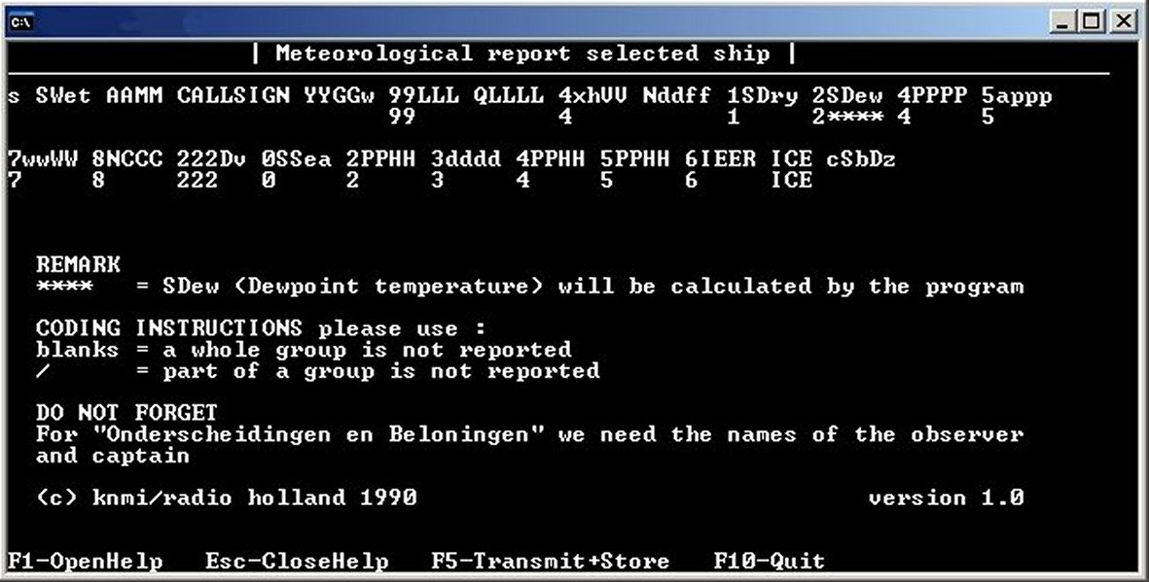
The principle of the program was straightforward. The observation could be made in the same way as filling in the meteo logbook. A difference was, however, that now for every element a help-screen could be consulted instead of going through tables and code books. Next, if applicable, the correct code number could be inserted in the right place. The code card, as it was used on board until then, was now embedded in the program in a structured way. When the observation was keyed in, it could be stored in one keystroke and, after selecting the appropriate Land-Earth Station, be transmitted. Before this was done, the program checked the observation on errors and inconsistencies. When everything was all right, the observation was stored on a diskette and after that the program – that by the way ran from the same 3.5 inch diskette – converted the observation in a ‘transmission format’. After selecting the Land-Earth Station, the observation could be transmitted by the Inmarsat-C terminal in which the diskette was located. As communication device, Inmarsat-C was a good candidate because this system was required on most ships under GMDSS. With Turbo2 it was possible to assemble and transmit the observation directly from the Inmarsat-C terminal. In fact Turbo2 used the internal processor of the Inmarsat-C terminal.
After a short trial period in 1990-1991, where three Dutch Shell tankers and the Dutch weather ship Cumulus were used as test ships, Turbo2 was distributed over the Dutch VOS-fleet. Also copies were sent to some countries that showed interest in the development of this system. In general the users were very positive. While computers were getting better and user-friendlier, KNMI received many suggestions to improve the program. Turbo2 was developed further and regularly new releases, with more possibilities and better adapted for the use by the observers, were disseminated. Parallel to Turbo2 other experiments were carried out. Turbo5, a Turbo2 version for fixed platforms (5: Fixed station Version), and Turbo6 (Surface current Indexing), a replacement of the paper ocean current logbook, appeared. Despite a short collaboration with the British Met Office, in which a module ‘trackob’ was appended to Turbo6, this product was not used very long. WMO decided to end the traditional way of collecting current data at the end of last century.
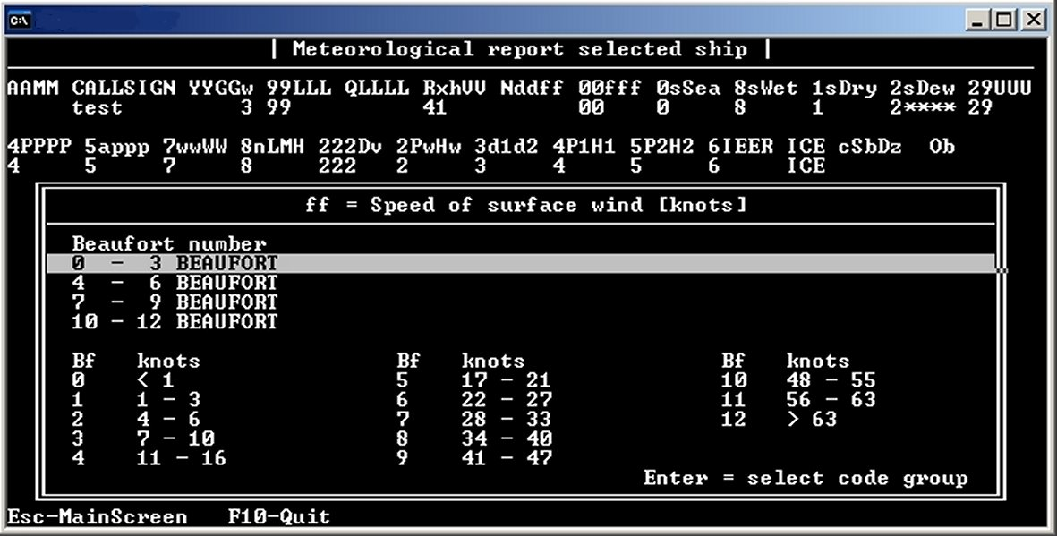
The fact that Turbo2 ran on the Inmarsat-C terminal eventually caused a problem. It was not allowed to use the Inmarsat-C terminal for these purposes anymore. Therefore the development of Turbo2 was changed into Turbo1 (Observation with New Efficiency), that ran on a separate computer/laptop and copied the observation to a diskette. This same diskette could then be read by the Inmarsat-C terminal and could be transmitted free of errors. For convenience Turbo5 was integrated into Turbo1.
Towards the end of last century, MsWindows pushed the old MsDos into the background and the demand for a more graphical oriented version of Turbo1 became more prominent. The original programs that were written in TurboPascal, were rewritten, but now in C++, an object oriented language. TurboWin made her first appearance on the Dutch fleet in 1997. Other counties were also captivated by this version of the program and with the aid of – among others – Australia, New Zealand, Germany, France and the United Kingdom, the first TurboWin version was build up to what it is now. Despite modernization, ships that didn’t follow the development of automation that fast had to be taken into account. We therefore still see many versions coexisting on the VOS fleet. And even at present there still are ships that, despite our encouragement to upgrade to the most recent version, still work with Turbo1.
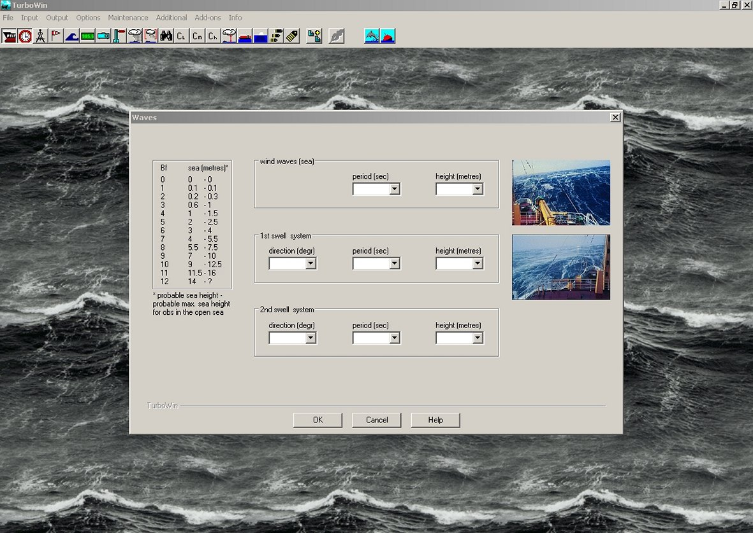
In recent years several extras were added to TurboWin: MeteoClassify, a program with which the observer can test his knowledge on estimating wind force and classifying clouds and sea ice, and the Ocean Wave Atlas, in which users are offered a global wave climate atlas that is based on the ECMWF re-analyses (ERA-40). Next this was extended even more with the ERA-40 wind, temperature and precipitation charts and the ICOADS sea surface temperature charts. MetPub47 is an add-on that was developed to collect and exchange ship’s meta data in a standard fashion (XML).
The latest development is the TurboWin applet. The TurboWin software is then hosted by a central server ashore and one can log in on board through a broadband internet connection. The development of the TurboWin applet is scarcely out of the egg, but since an increasing number of ships are already equipped with broadband internet, it is investigated how to make use of that.
The table below shows the development of Turbo2 into TurboWin over the years. The table is far from complete, but it shows the most important releases. More information can be found on the TurboWin website: http://www.knmi.nl/turbowin

Turbo2 | Turbo1 | Turbo5 | Turbo6 | TurboWin | Various | Released
1.0 |  |  |  |  |  | Oct 1990
1.2 |  |  |  |  |  | Sep 1990
 | 1.22 |  |  |  |  | Nov 1990
 |  | 1.35 |  |  |  | Sep 1991
 |  |  | 1.0 |  |  | Mar 1992
2.0 |  |  |  |  |  | Aug 1992
 |  |  |  |  | LOCDAP 1.0 | Dec 1992
 | 2.0 |  |  |  |  | Nov 1993
 |  |  |  |  | LOCDAP 2.0 | Mar 1994
 | 3.0 |  |  |  |  | Sep 1994
 |  | 3.2 |  |  |  | May 1995
 |  |  |  | 1.0 |  | Jan 1996
 |  |  | 1.2 trackob |  |  | 1996
 | 4.0 |  |  |  |  | May 1996
 | 4.52 |  |  |  |  | Mar 1999
 |  |  |  | 1.5
 |  |  |  | 1.7
 |  |  |  | 1.71 |  | Jul 2000
 |  |  |  | 2.0 |  | Feb 2001
 |  |  |  | 2.1
 |  |  |  | 3.0 |  | Apr 2002
 |  |  |  |  | MeteoClassify 1.01 | Jun 2003
 |  |  |  |  | Ocean Wave Atlas 1.0 | Sep 2003
 |  |  |  |  | Ocean Wave Atlas 2.0 | Apr 2004
 |  |  |  | 3.5 |  | Aug 2004
 |  |  |  | 3.6
 |  |  |  |  | MetPub47 0.5b | Mar 2006
 |  |  |  |  | MeteoClassify 2.0 | May 2005
 |  |  |  |  | MeteoClassify 2.1 | Oct 2006
 |  |  |  |  | Ocean Wave Atlas 2.1 | Nov 2006
 |  |  |  |  | Global Climate Atlas 1.0 | Nov 2006
 |  |  |  | 4.0 |  | Jan 2007
 |  |  |  |  | MetPub47 1.1 | Feb 2007
 |  |  |  |  | TurboWin applet | 2007
 |  |  |  | 4.1
 |  |  |  | 4.5 |  | Dec 2009

